**MACHINE LEARNING (IP#3)**

**STUDENT ID: 700766162**

**NAME: SRAVANI MANNURU**

Github link: https://github.com/sravs2031/Machine-learning-Assignment-3.git

Video link: https://drive.google.com/file/d/1jm-uy-ms5lpfCCR5eA85LKQf_qsb70jC/view?usp=drive_link

**Screenshots:**

**a)**

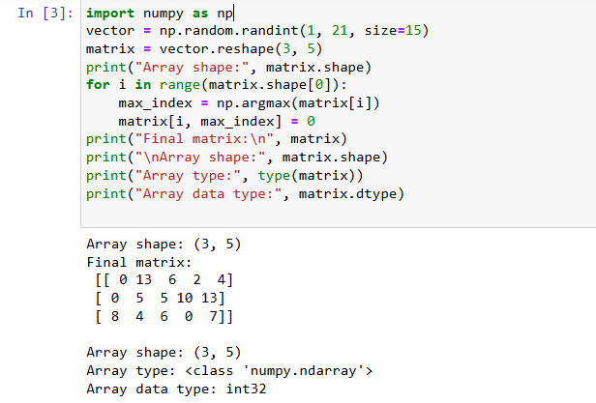

b)

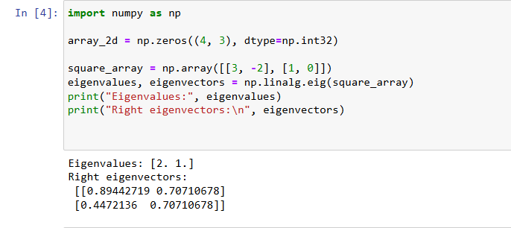

c)

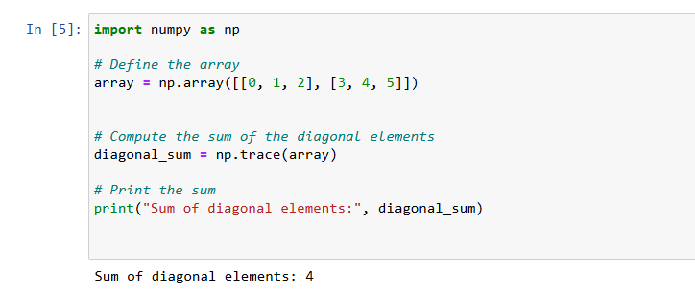

d)

